**Name- Ishika Devare RollNo- 70 Lab Exercise 2**

**Title:** Assignment on CSS

**Objectives:**

1. Develop a HTML page to create a Profile page and style the page. ( External CSS inclusion, placement : margins, padding, all type of selectors including pseudo elemnts, Gradient, Border: Rounded Border, web fonts)
2. Design a HTML form to take inputs to place orders for Customized T shirts. Accept fields like Tagline on the shirt, color, size, quantity, date and other details of delivery etc. (include Internal/ inline CSS inclusion, all types of selectors including pseudo classes ).

**Theory:**

1. **What benefits and demerits do External Style Sheets have?**

The advantages of External Style Sheets are:  
  
- Using them, the styles of multiple documents can be controlled from one file.  
- Classes can be created for use on multiple HTML element types in many documents.  
- In complex situations, selector and grouping methods can be used to apply styles.  
  
The disadvantages of External Style Sheets are:  
  
- In order to import style information for each document, an extra download is needed.  
- Until the external style sheet is loaded, it may not be possible to render the document.  
- For small number of style definitions, it is not viable.

1. **What happens when content is placed as inline, inline-block or block?**

**Inline-**

Displays an element as an inline element. Any height and width properties will have no effect. This one displays the element inline or on the same line. In other words, inline elements do NOT start on a new line and only takes up as much width as its content. So, if you try to set any width and height, it will have NO effects.

**inline-block-**

Displays an element as an inline-level block container. one can set height and width values. It’s essentially the same thing as inline, except that you can set height and width values.

**Block-**

block starts on a NEW line and takes up the full width available. So that means block elements will occupy the entire width of its parent element.

1. **What are the different types of Selectors in CSS?**

CSS Selectors are divided into five categories:

1. **Simple Selectors (select elements based on name, id, class)**

**The CSS id Selector-**

The id selector uses the id attribute of an HTML element to select a specific element.

The id of an element is unique within a page, so the id selector is used to select one unique element!

To select an element with a specific id, write a hash (#) character, followed by the id of the element.

**The CSS class Selector-**

The class selector selects HTML elements with a specific class attribute.

To select elements with a specific class, write a period (.) character, followed by the class name.

**The CSS Universal Selector-**

The universal selector (*) selects all HTML elements on the page.

**The CSS Grouping Selector-**

h1 {

text-align: center;

color: red;

}

h2 {

text-align: center;

color: red;

}

p {

text-align: center;

color: red;

}

1. Combinator selectors (select elements based on a specific relationship between them)

**Descendant Selector**

The descendant selector matches all elements that are descendants of a specified element.

div p {

background-color: yellow;

}

**Child Selector (>)**

The child selector selects all elements that are the children of a specified element.

div > p {

background-color: yellow;

}

**Adjacent Sibling Selector (+)**

The adjacent sibling selector is used to select an element that is directly after another specific element.

Sibling elements must have the same parent element, and "adjacent" means "immediately following".

div + p {

background-color: yellow;

}

**General Sibling Selector (~)**

The general sibling selector selects all elements that are next siblings of a specified element.

div ~ p {

background-color: yellow;

}

1. Pseudo-class selectors (select elements based on a certain state)

**What are Pseudo-classes?**

A pseudo-class is used to define a special state of an element.

For example, it can be used to:

Style an element when a user mouses over it

Style visited and unvisited links differently

Style an element when it gets focus

**Hover on <div>**

div:hover {

background-color: blue;

}

**Match the first <p> element**

p:first-child {

color: blue;

}

**Match the first <i> element in all <p> elements**

p i:first-child {

color: blue;

}

**Match all <i> elements in all first child <p> elements**

p:first-child i {

color: blue;

}

1. Pseudo-elements selectors (select and style a part of an element)

**What are Pseudo-Elements?**

A CSS pseudo-element is used to style specified parts of an element.

For example, it can be used to:

Style the first letter, or line, of an element

Insert content before, or after, the content of an element

The :: first-line Pseudo-element

The :: first-line pseudo-element is used to add a special style to the first line of a text.

The ::first-letter Pseudo-element

The ::first-letter pseudo-element is used to add a special style to the first letter of a text.

The ::before Pseudo-element

The ::before pseudo-element can be used to insert some content before the content of an element.

The ::after Pseudo-element

The ::after pseudo-element can be used to insert some content after the content of an element.

The ::marker Pseudo-element

The ::marker pseudo-element selects the markers of list items.

The ::selection Pseudo-element

The ::selection pseudo-element matches the portion of an element that is selected by a user.

The following CSS properties can be applied to ::selection: color, background, cursor, and outline.

1. Attribute selectors (select elements based on an attribute or attribute value)

**CSS [attribute="value"] Selector**

The [attribute="value"] selector is used to select elements with a specified attribute and value.

**CSS [attribute~="value"] Selector**

The [attribute~="value"] selector is used to select elements with an attribute value containing a specified word.

**CSS [attribute|="value"] Selector**

The [attribute|="value"] selector is used to select elements with the specified attribute, whose value can be exactly the specified value, or the specified value followed by a hyphen (-).

**CSS [attribute*="value"] Selector**

The [attribute*="value"] selector is used to select elements whose attribute value contains a specified value.

1. **What are the elements of the CSS Box Model?**

In CSS, the term "box model" is used when talking about design and layout.

The CSS box model is essentially a box that wraps around every HTML element. It consists of: margins, borders, padding, and the actual content. The image below illustrates the box model:

Explanation of the different parts:

Content - The content of the box, where text and images appear

Padding - Clears an area around the content. The padding is transparent

Border - A border that goes around the padding and content

Margin - Clears an area outside the border. The margin is transparent

Example-

div {

width: 300px;

border: 15px solid green;

padding: 50px;

margin: 20px;

}

1. **What are Pseudo elements and Pseudo classes?**

**What is a pseudo-class?**

A pseudo-class is a selector that selects elements that are in a specific state, e.g. they are the first element of their type, or they are being hovered over by the mouse pointer. They tend to act as if you had applied a class to some part of your document, often helping you cut down on excess classes in your markup, and giving you more flexible, maintainable code.

Pseudo-classes are keywords that start with a colon:

:pseudo-class-name

* :hover — mentioned above; this only applies if the user moves their pointer over an element, typically a link.
* :focus — only applies if the user focuses the element by clicking or using keyboard controls.

**What is a pseudo-element?**

Pseudo-elements behave in a similar way. However, they act as if you had added a whole new HTML element into the markup, rather than applying a class to existing elements. Pseudo-elements start with a double colon ::.

::pseudo-element-name

**Hosted Page:**

GitHub Repo for Assignment 1: <https://github.com/ishikadevare13/Assignments>

Hosted link of Assignment 1: <https://ishikadevare13.github.io/Assignments/ass_3/profile.html>

GitHub Repo for Assignment 2: [https://github.com/ishikadevare13/Assignments](%20https:/github.com/ishikadevare13/Assignments)

Hosted link of Assignment 2: <https://ishikadevare13.github.io/Assignments/ass_4/index.html>

**Code with Screenshot:**

**Assignment 1:**

**Profile.html**

<html>

<head>

<link rel="stylesheet" href="profile.css">

</head>

<body>

<div class="container">

<header>This is my profile page </header>

<ul>

<li><a class="active" href="#self">About Me</a></li>

<li><a href="#skills">My skills</a></li>

<li><a href="#sign">Signature</a></li>

<li><a href="#lang">Languages known</a></li>

<li><a href="#contact">Contact through</a></li>

</ul>

<h1>Ishika Devare</h1>

<h3>Personal Profile</h3>

<figure><a href="https://imgbb.com/"><img src="https://lh3.googleusercontent.com/a-/AFdZucq9eM5_6WLAt7ohL9_ieLaCvURlXffGHVTIEykP=s360-p-rw-no" alt="profile-picture" border="0" /></a><section></section>

<figcaption> profile picture </figcaption>

</figure>

<h4 class="sign">Signature</h4>

<a href="https://imgbb.com/" ><img src="signature.svg" /></a><br/><br/>

<h4 id="self">About Me</h4>

<p> Hi, I'm Ishika Devare I have a huge passion for web-development and programming. I love to learn and thrive from challenges. I am completing my B.E from Vivekanand Education Societys Institute of Technology. </p>

</header>

<fieldset>

<br>

<div class="listFlex">

<h4 id="skills">My Skills</h4>

<div>

<h5> Technical Skills </h5>

PHP <br>

HTML <br>

CSS <br>

JavaScript <br>

JavaScript <br>

<nav>

<a href="https://www.w3schools.com/html/">HTML</a>

</nav>

</div>

<h5> Personal Skills </h5>

Dance <br> Badminton <br> Swimming <br> Reading <br> Singing

</fieldset>

<h5 id="lang"> Languages known: </h5>

<table>

<tr>

<th>Languages</th>

<th>Levels</th>

</tr>

<tr>

<td>English</td>

<td>Advanced</td>

</tr>

<tr>

<td>Hindi</td>

<td>Advanced</td>

</tr>

<tr>

<td>Marathi</td>

<td>Advanced</td>

</tr>

<tr>

<td>German</td>

<td>Beginner</td>

</tr>

</table>

<br>

<h5 id="contact"> Connect me through- </h5>

<div class="listflex">

<button>

<a href="https://api.whatsapp.com/send?phone=+917021734119"

target="_blank">

<img src="https://upload.wikimedia.org/wikipedia/commons/thumb/6/6b/WhatsApp.svg/1200px-WhatsApp.svg.png"

alt="whatsapp"

width="30"

height="30"

title="Whatsapp"/>

</a></button>&nbsp&nbsp&nbsp<h6> Whatsapp </h6></div>

<div class="listflex">

<button>

<a href="https://www.linkedin.com/in/ishika-devare-8a77a4245/" target="_blank">

<img src="linkedin-logo-2430.svg"

alt="Linked In"

width="30"

height="30"

title="Linked In"/>

</a></button>&nbsp&nbsp&nbsp<h6> Linked In </h6></div>

<h5>Video </h5>

<iframe width="420" height="315"

src="https://www.youtube.com/embed/88PXJAA6szs">

</iframe>

<footer>

Ishika Devare

</footer>

</div>

</body>

</div>

</html>

**Profile.css**

*

{

box-sizing: border-box;

}

body

{

font-family: Georgia;

margin-left: 80px;

text-align: left;

background-image: linear-gradient(to bottom right, lightblue, blue);

border: 10px solid black;

margin: 15px 0px;

border-height: 25px 10px 4px 35px;

border-radius: 35px;

}

img

{

border-radius: 50px;

}

table, th, td

{

border:1px solid black;

}

.listflex {

padding: 30px;

border: 1px solid black;

width: 150px;

}

table, th, td {

border: 1px solid black;

}

fieldset {

width: 100px;

}

.column {

float: left;

width: 50%;

padding: 10px;

height: 300px; /* Should be removed. Only for demonstration */

}

/* Clear floats after the columns */

.row:after {

content: "";

display: table;

clear: both;

}

p::first-line {

color: red;

}

p::first-letter {

color: yellow;

font-size: xx-large;

}

footer{

border: 1px black;

border-radius: 25px;

}

ul {

list-style-type: none;

margin: 0;

padding: 0;

overflow: hidden;

background-color: #333;

}

li {

float: left;

}

li a {

display: block;

color: white;

text-align: center;

padding: 14px 16px;

text-decoration: none;

}

li a:hover {

background-color: #111;

}

.container {

padding: 30px;

}

**Output-**

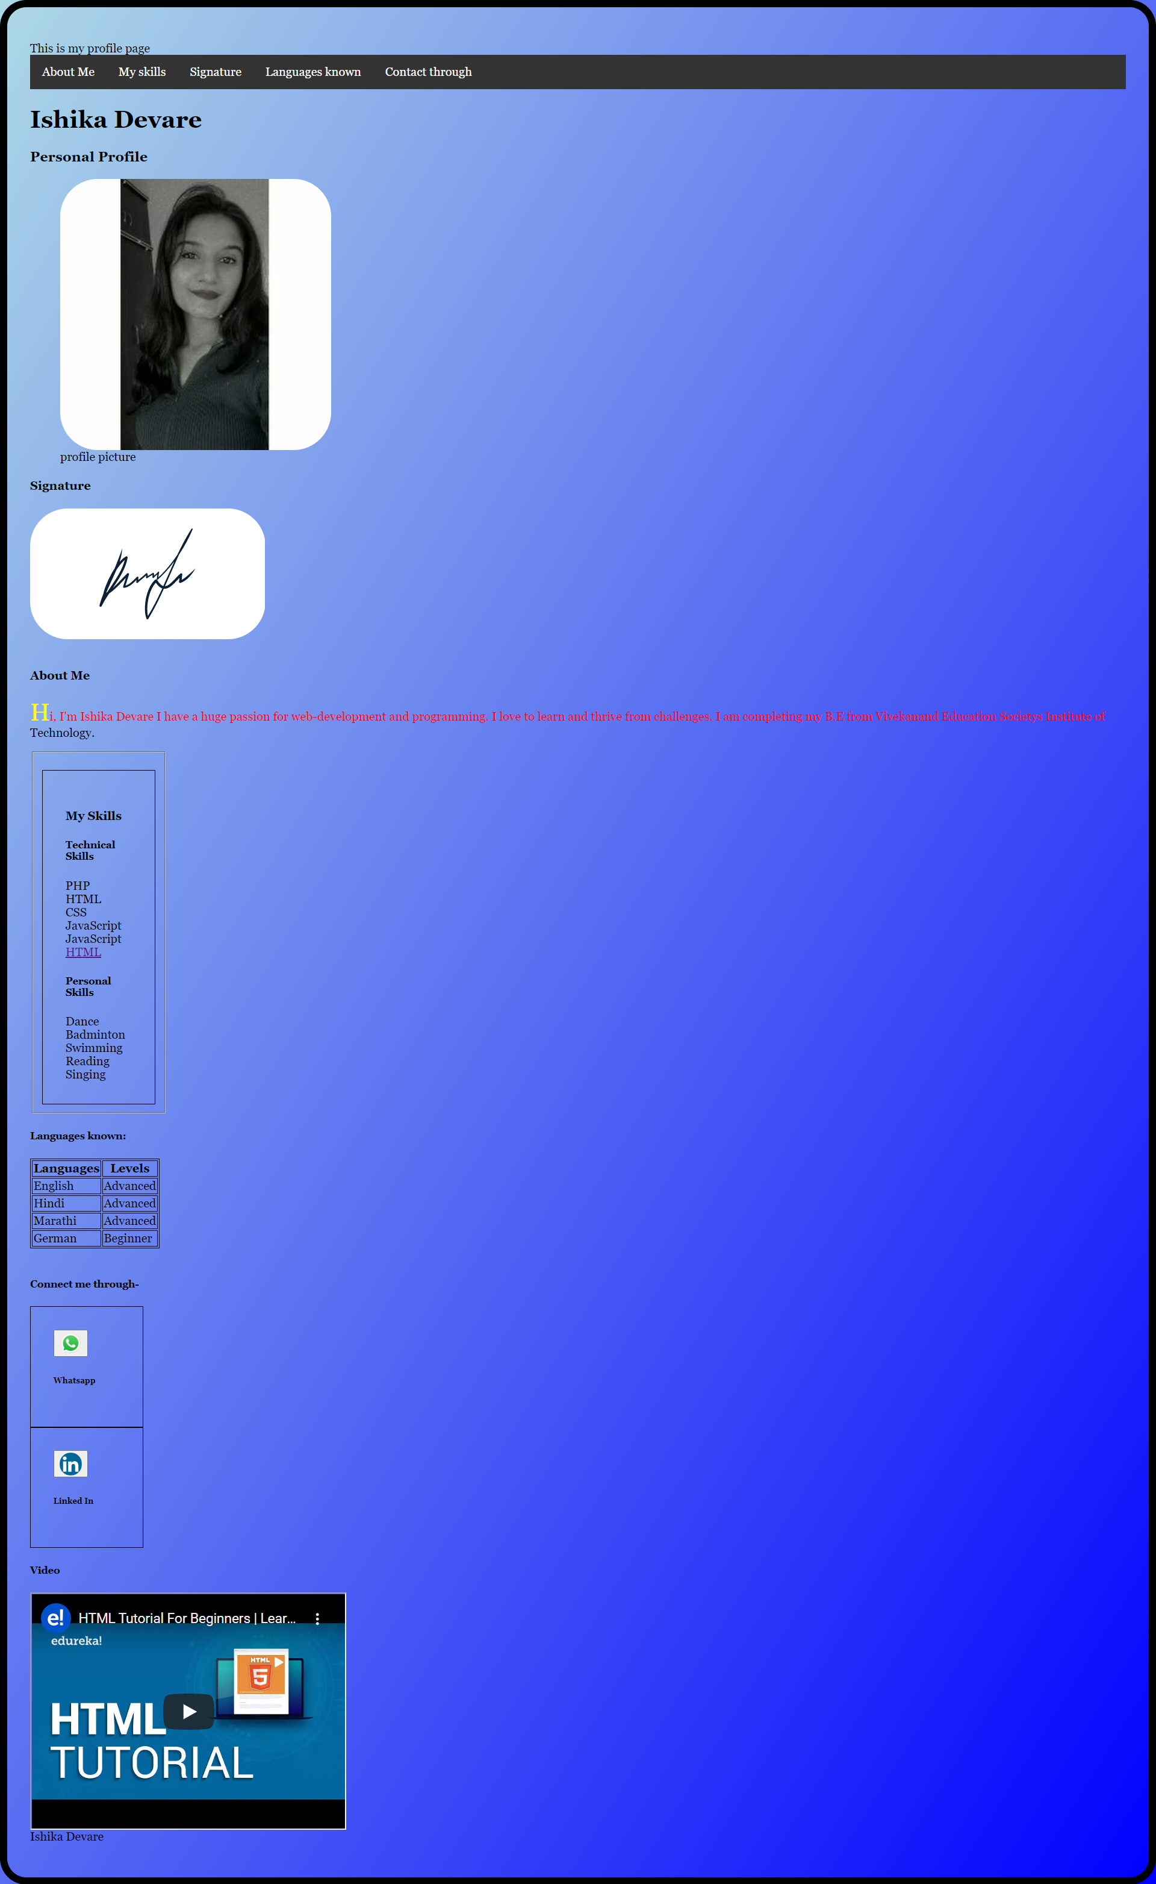

**Assignment 2:**

**Index.html**

<html>

<head>

<title> Customized Tshirts Shop</title>

<style>

* { font-size: 17px ;}

body { background-image: linear-gradient(120deg, #d4fc79 0%, #96e6a1 100%);}

textarea { resize: None ;}

form.center {text-align: center };

</style>

</head>

<body>

<form class="center" oninput="res.value = parseInt(quantity.value) * 150; " >

<h1 style="font-size: 2em; color: white; background-color: maroon;">Customized T-shirts</h1>

<img style=" width: 250px; border: 5px solid #555" src="https://i.pinimg.com/originals/a4/fc/ed/a4fced78432efaea701c4efa2af93a14.png"><br><br>

<label for="tagline"> Tagline for front: </label>

<input type="text" id="tagline" name="tagline" placeholder="Enter tagline" required><br><br>

<label for="tagline"> Tagline for back: </label>

<input type="text" id="tagline" name="tagline" /><br><br>

<label for="color"> Color for tshirt: </label>

<input type="color" id="color" name="color" required /><br><br>

<label for="cars">Tshirt Styles: </label>

<select name="tshirts" id="cars" required>

<optgroup label="Half Sleeves">

<option value="vneck">V Neck</option>

<option value="rneck">Round Neck</option>

<option value="htshirt">Hoodie Tshirt</option>

</optgroup>

<optgroup label="Full Sleeves">

<option value="vneck">V Neck</option>

<option value="rneck">Round Neck</option>

<option value="htshirt">Hoodie Tshirt</option>

</optgroup>

</select>

<br><br>

<label for="quantity"> Quantity for tshirt: </label>

<input type="number" id="quantity" name="quantity" min="1" max="50" required /><br><br>

<label for="size" class="required" required> Size: </label>

<input type="radio" id="small" name="sizee" value="HTML" />

<label for="small">Small</label>

<input type="radio" id="medium" name="sizee" value="medium" />

<label for="medium">Medium</label>

<input type="radio" id="xl" name="sizee" value="xl" />

<label for="xl">XL</label><br><br>

<label for="date"> Date: </label>

<input type="date" id="date" name="date" required /><br><br>

<label for="email">Email Id:</label>

<input type="email" id="em" name="email" placeholder="Enter emailid" required /> <br><br>

<label for="address"> Address: </label>

<textarea rows={3} cols={22} required></textarea> <br><br>

<label for="payment"> Payment Method: </label>

<select name="payment" id="pay" required>

<option value="emi">EMI</option>

<option value="cod">COD</option>

<option value="credit_card">Credit Card</option>

<option value="debit_card">Debit Card</option>

</select><br><br>

Total amount: <output name="res"></output> <br><br>

<label for="submit"></label>

<input type="submit" id="submit" name="submit" value: Submit required /><br><br>

</form>

</body>

</html>

**Output-**

